11TSP using Exhaustive Search
Aim
To implement the Travelling Salesman Problem (TSP) using Exhaustive Search and find the minimum-cost tour.
Algorithm
- Start.
- Initialize the distance matrix.
- Generate all possible routes from the starting city.
- Calculate the total cost of each route.
- Select the route with the minimum cost.
- Display the optimal route and minimum cost.
- Stop.
Procedure
- Define the number of cities and their distances.
- Fix city 0 as the starting city.
- Generate all permutations of the remaining cities.
- Calculate the total travel cost for each route, including the return to the starting city.
- Identify and display the minimum-cost route.
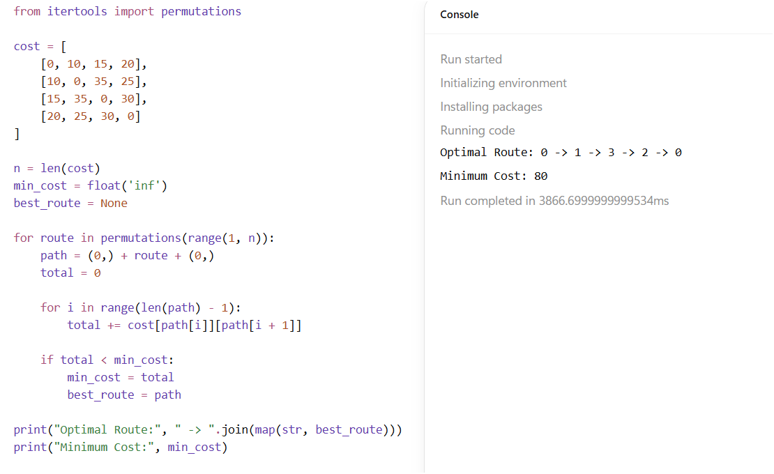
Result
The Travelling Salesman Problem was successfully solved using Exhaustive Search, and the minimum-cost tour was identified.

